***SQL DATA Queries***

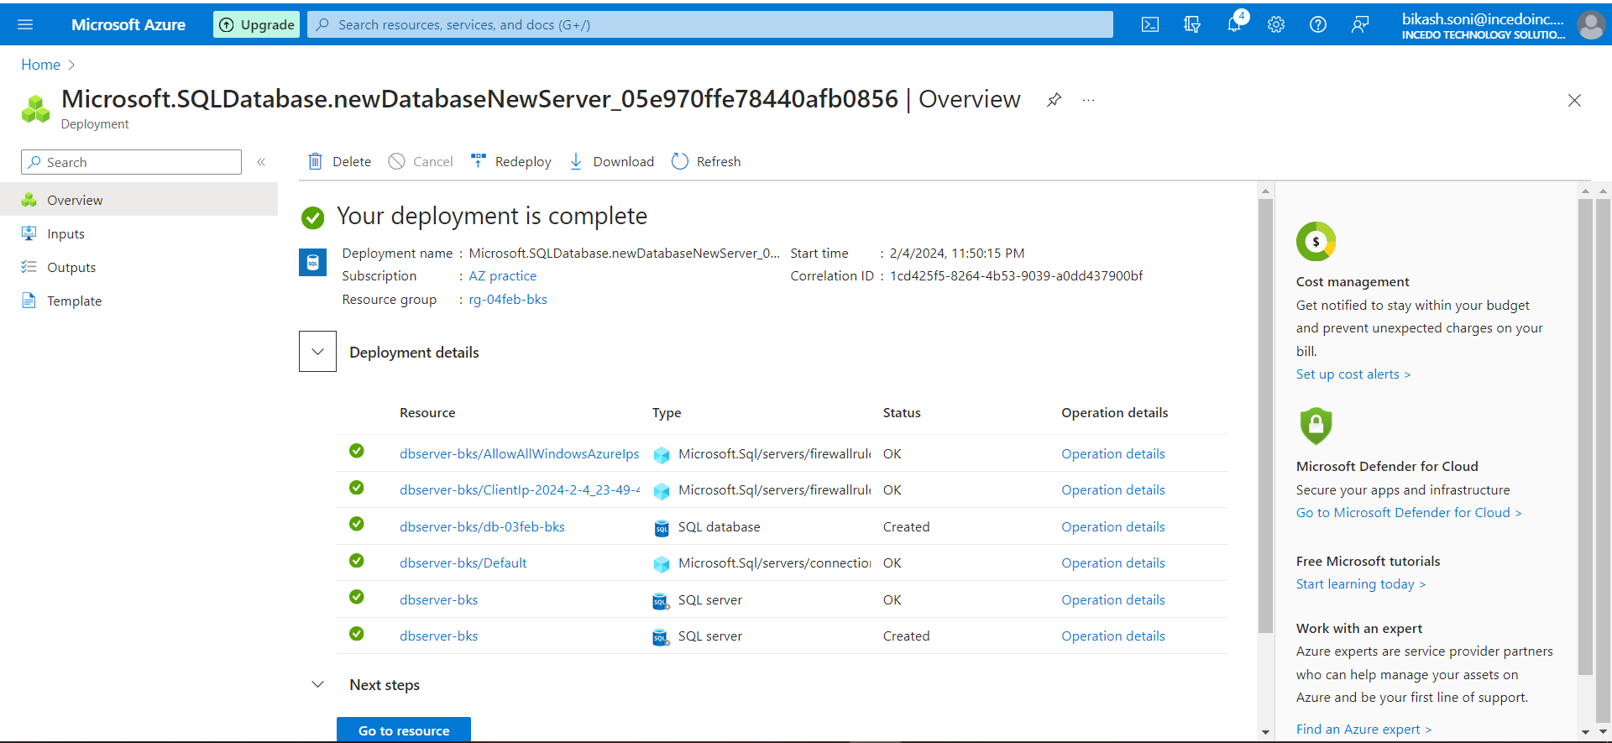

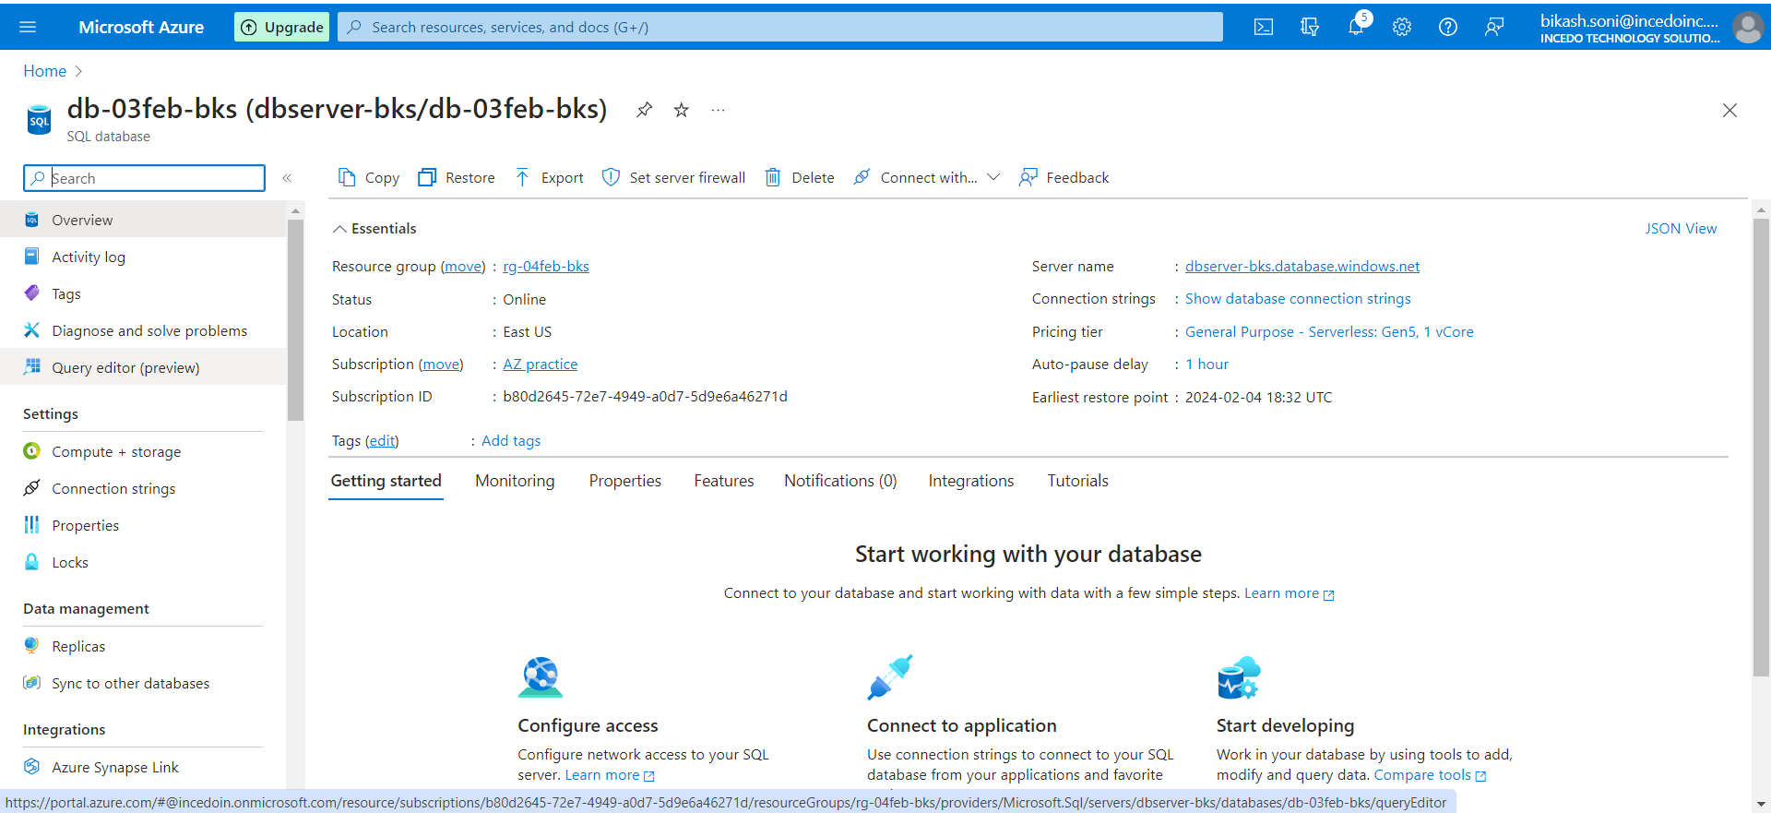

Creating the AZURE MSSQL database

**Module 1: Data Integrity checks**

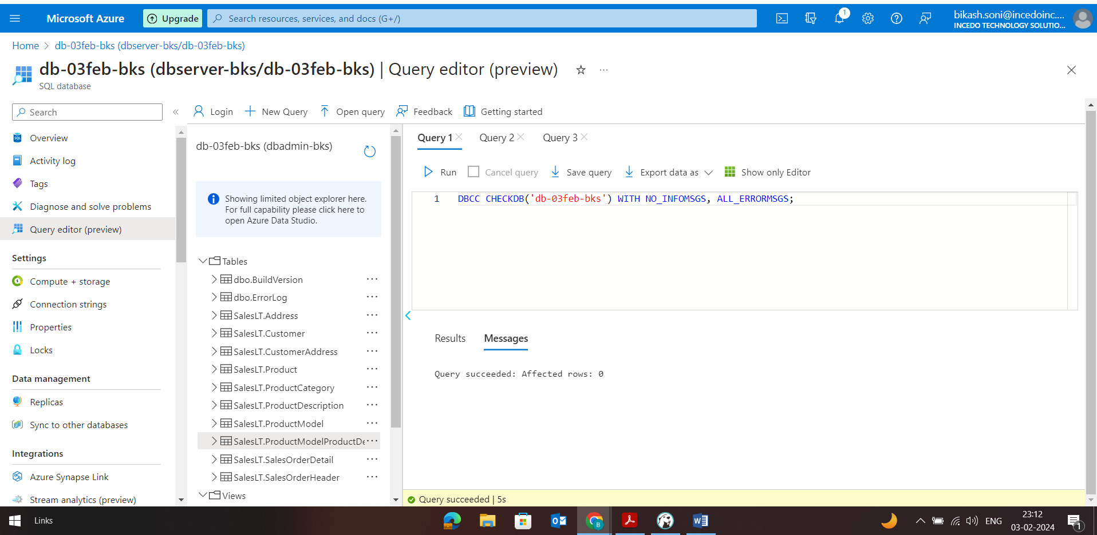

Checking Database integrity

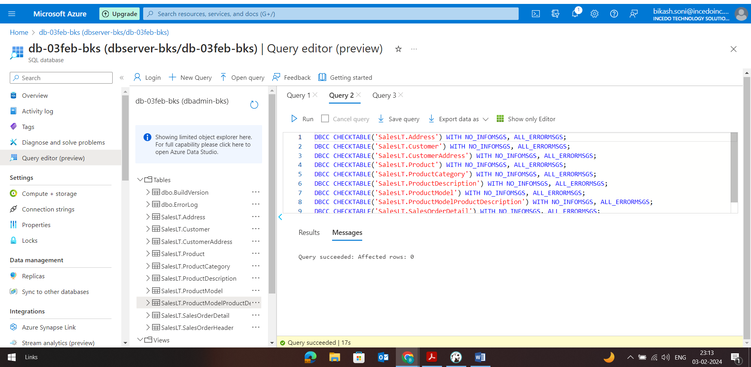

Checking Table integrity

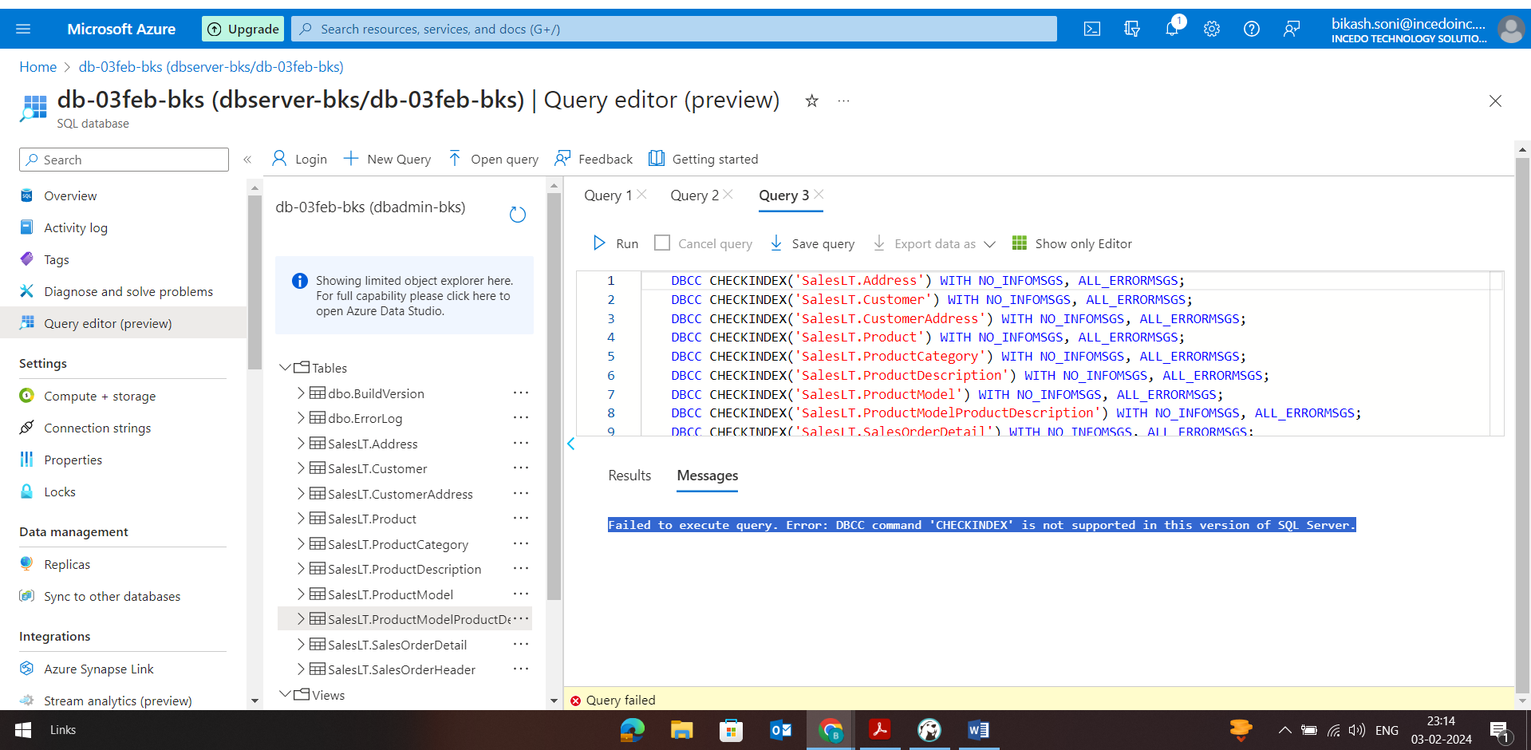

Checking Index Integrity

**Module 2:-**

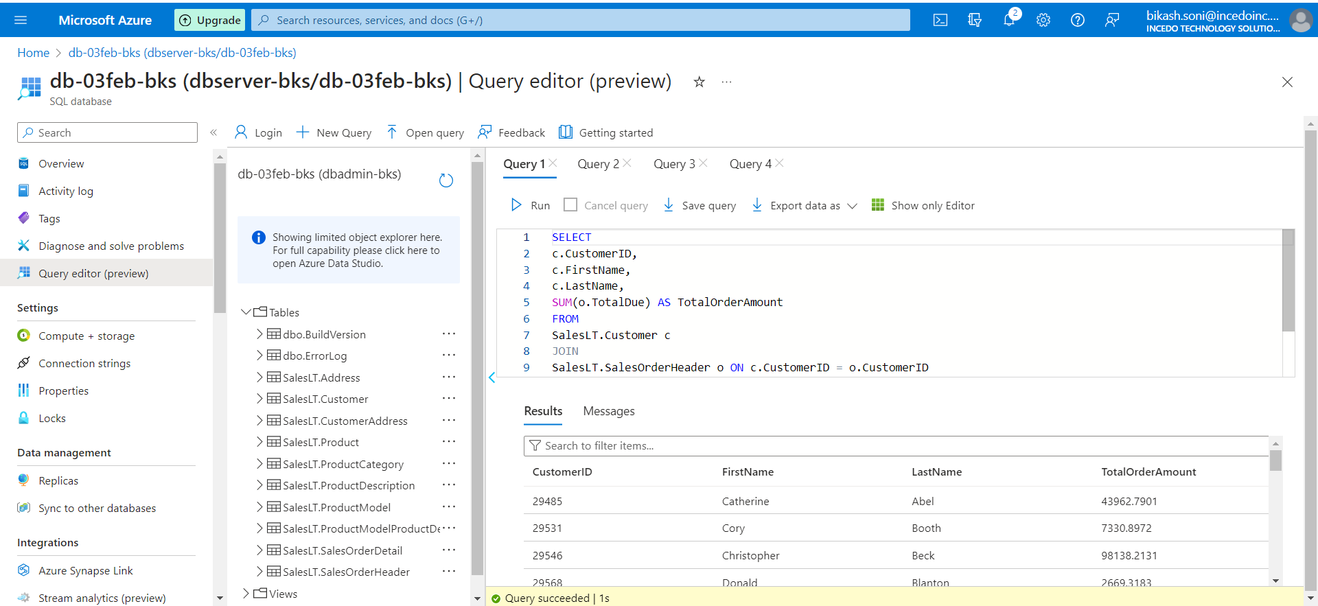

Retrieve a list of customers along with their total order amounts.

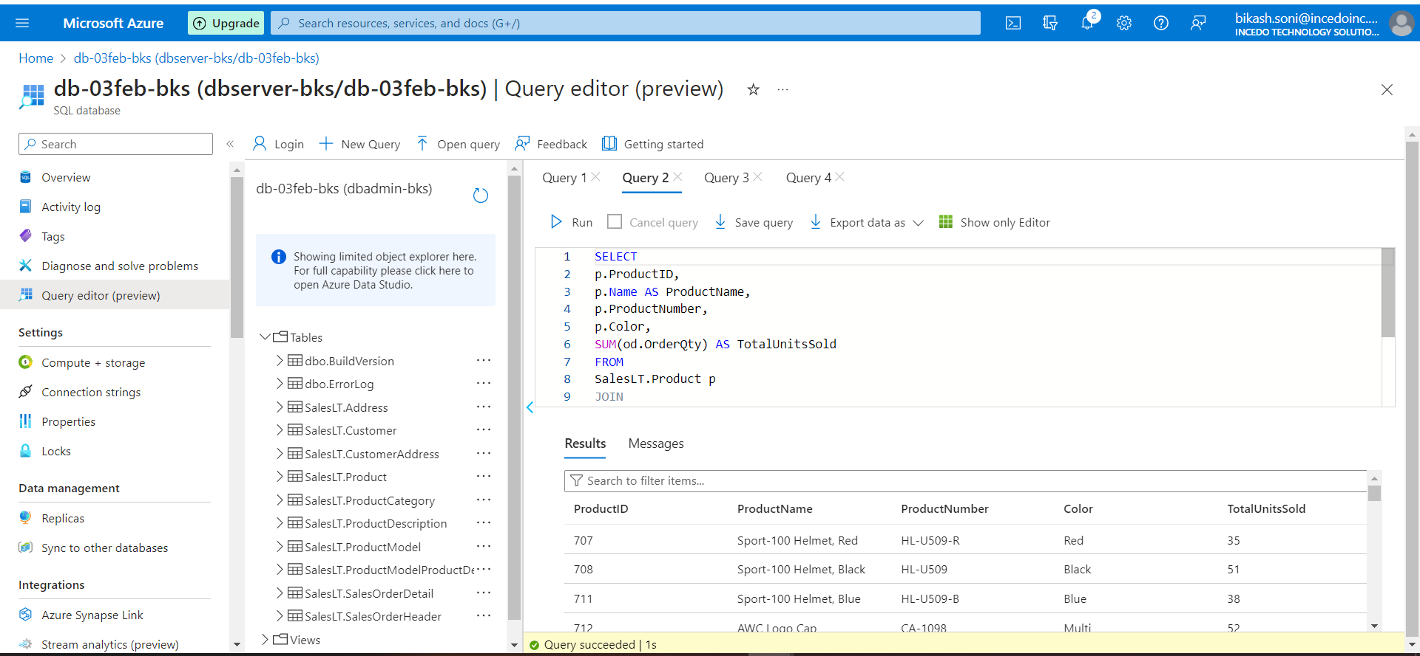

Display product information along with the number of units sold for each product.

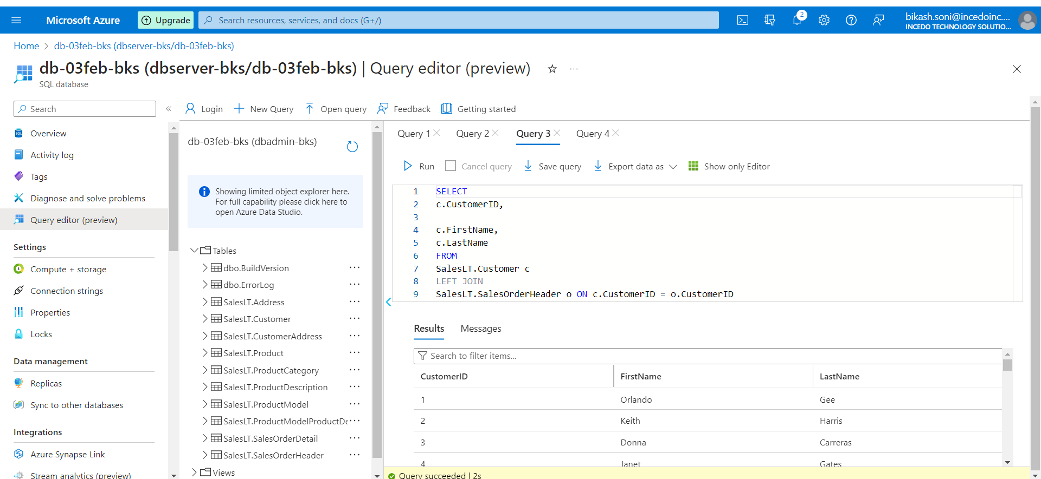

List all customers who have never placed an order.

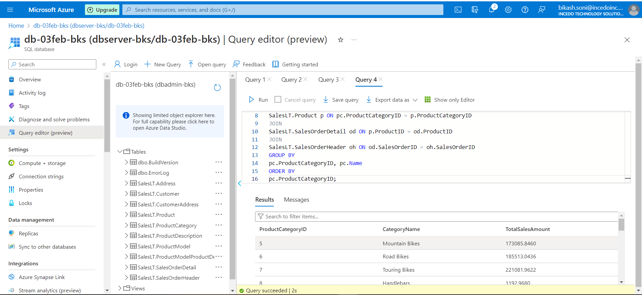

Retrieve the total sales amount for each product category.

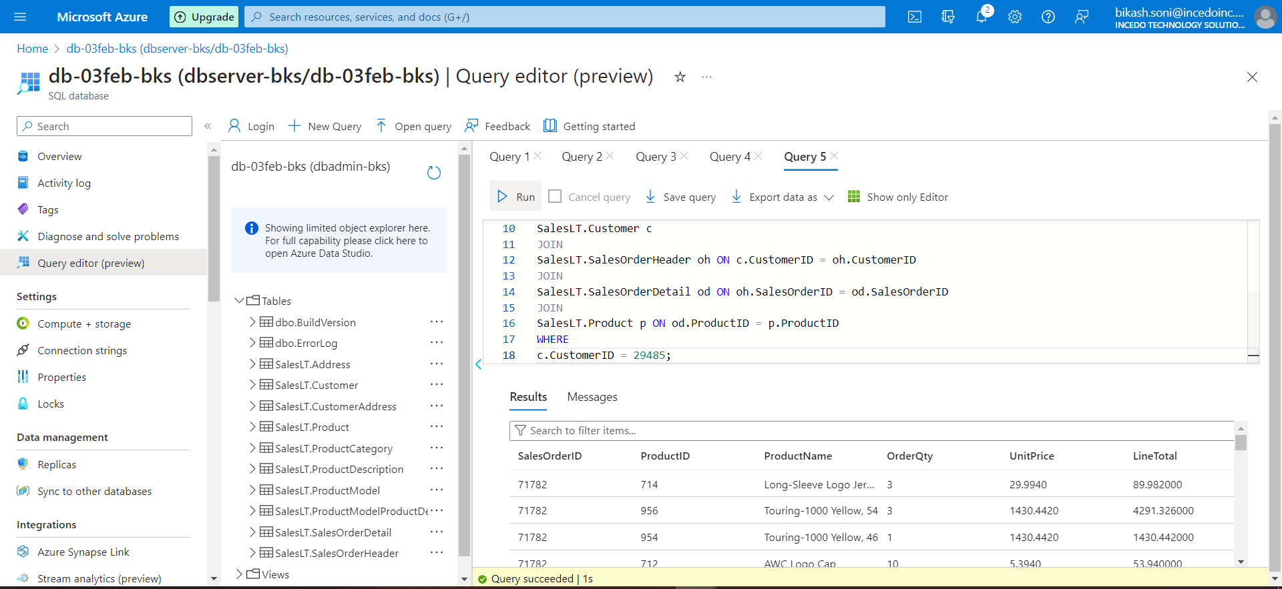

Show the order details with product names for a specific customer.

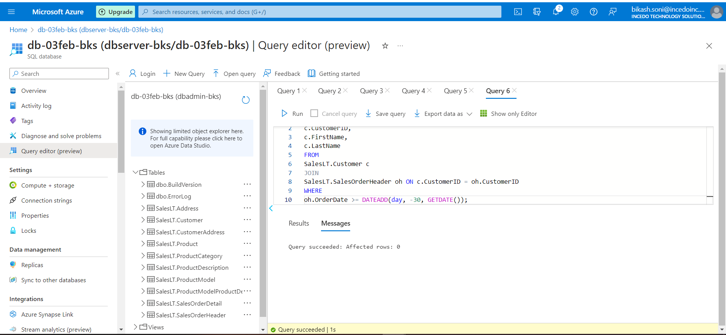

List customers who have made purchases in the last 30 days.

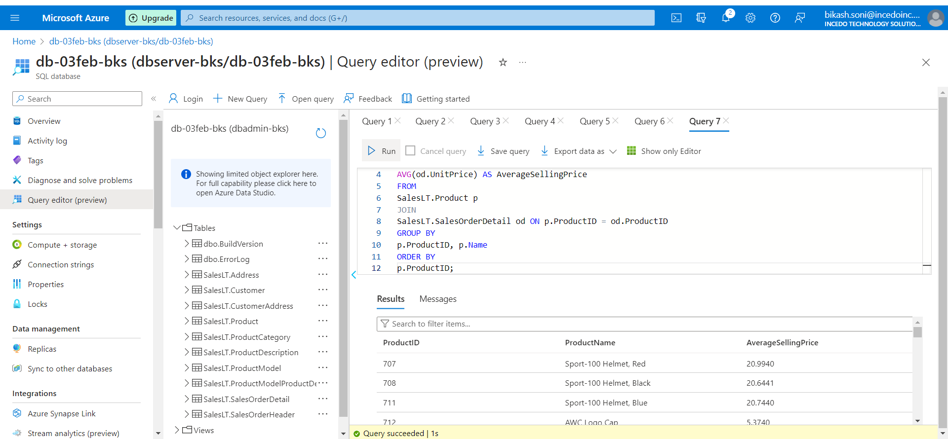

Retrieve all products along with their average selling prices.

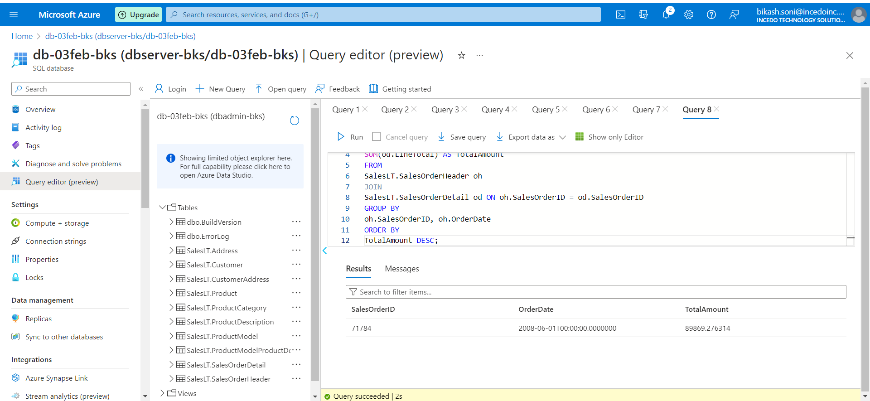

Find the order with the highest total amount.

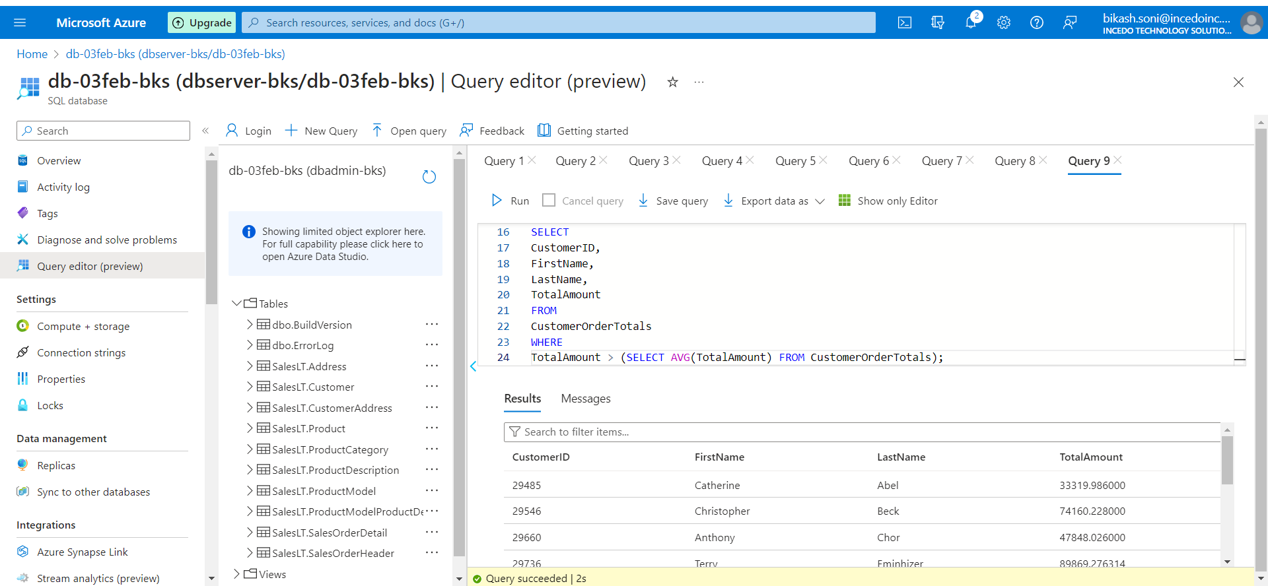

Display customers who have placed orders with a total amount greater than the average.

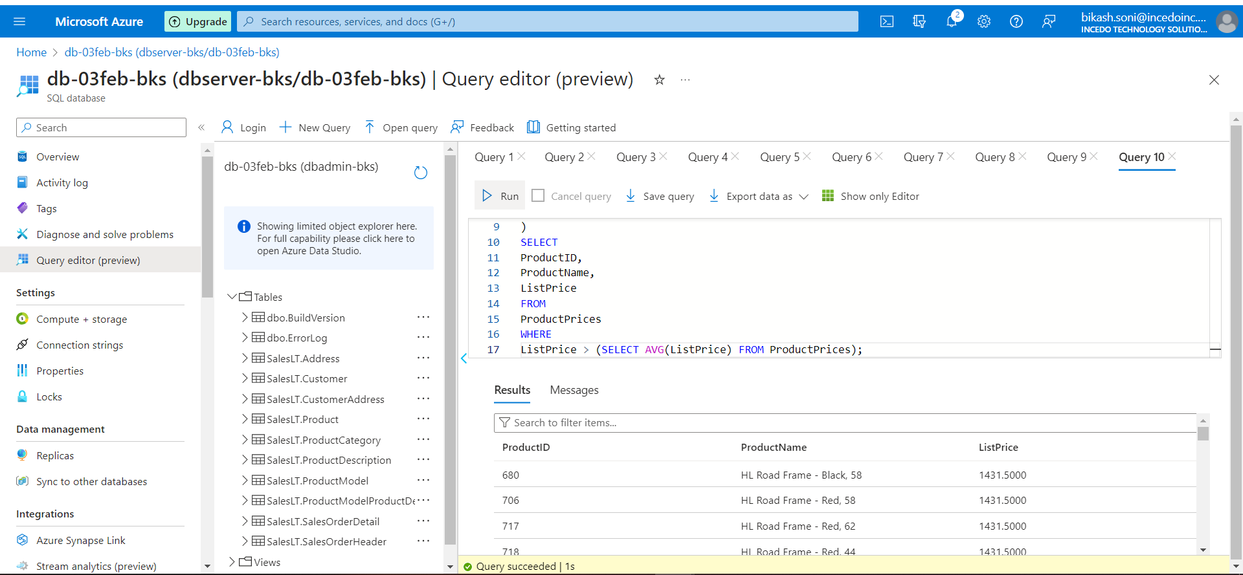

List products with prices higher than the average product price.

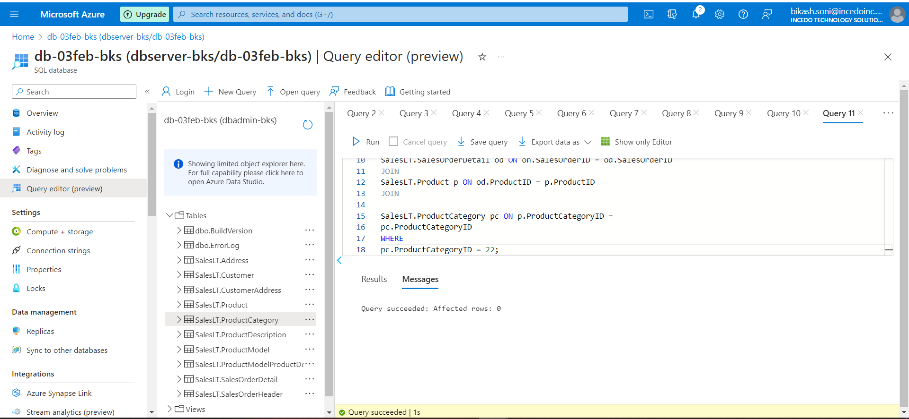

Display customers who have placed orders for a specific product category.

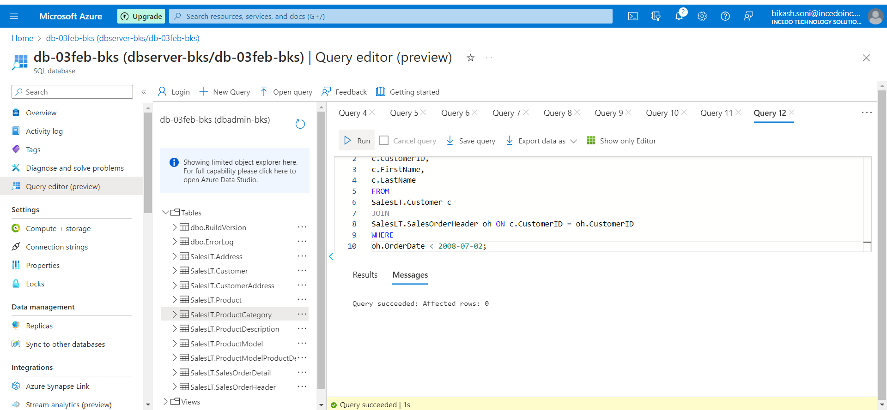

List customers who have placed orders before a specific date.

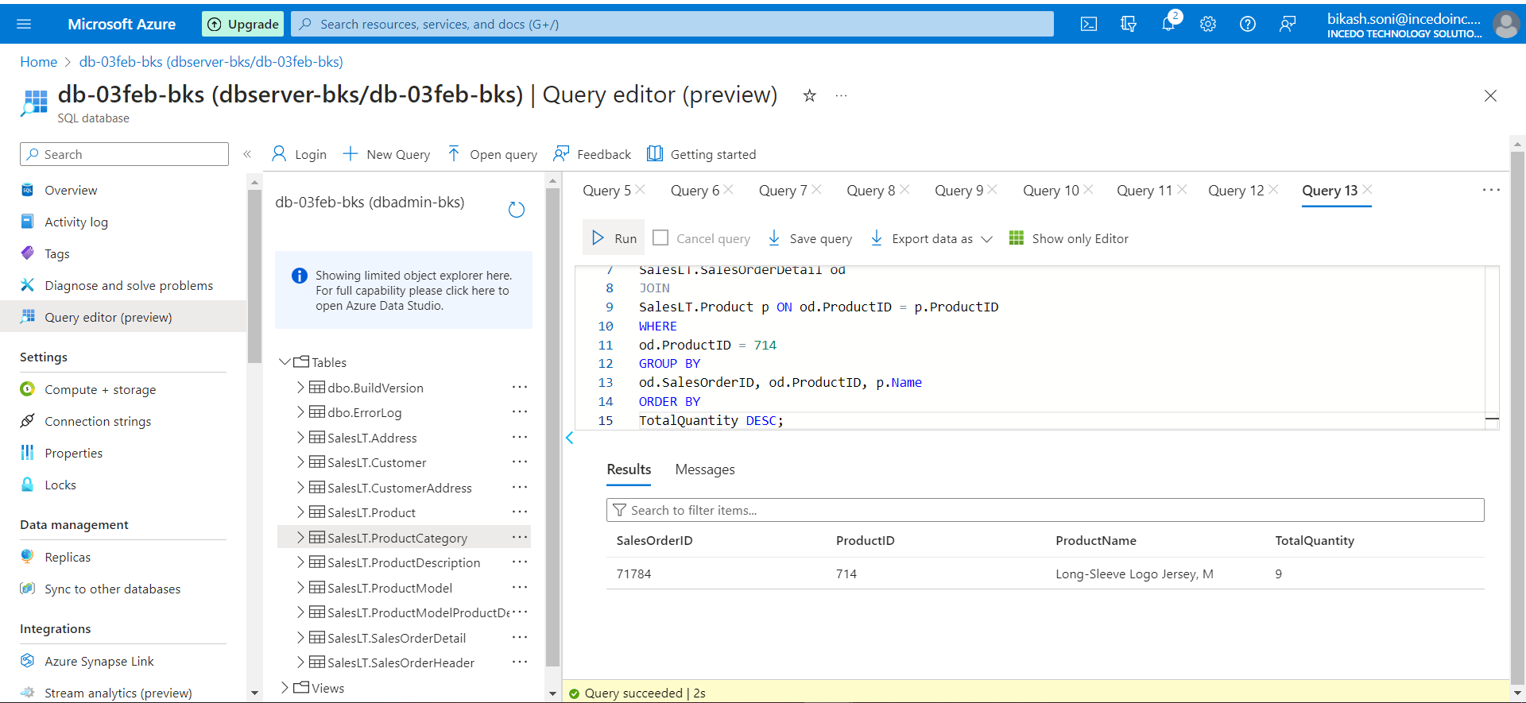

Retrieve the order with the highest quantity of a specific product.

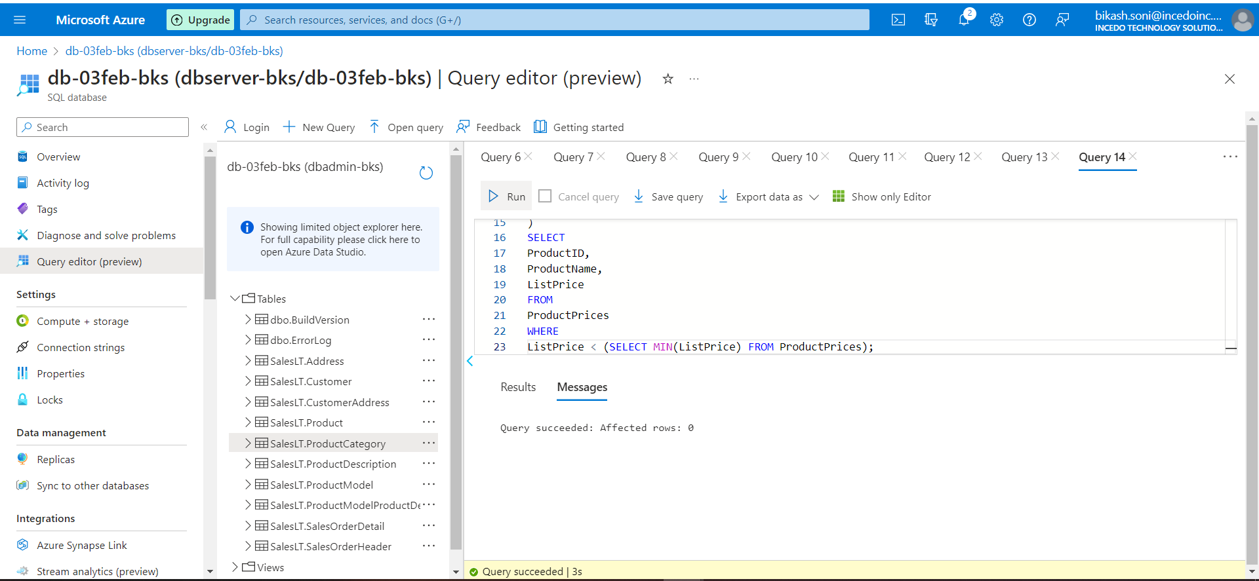

Display products with prices lower than the lowest product price in a specific category.

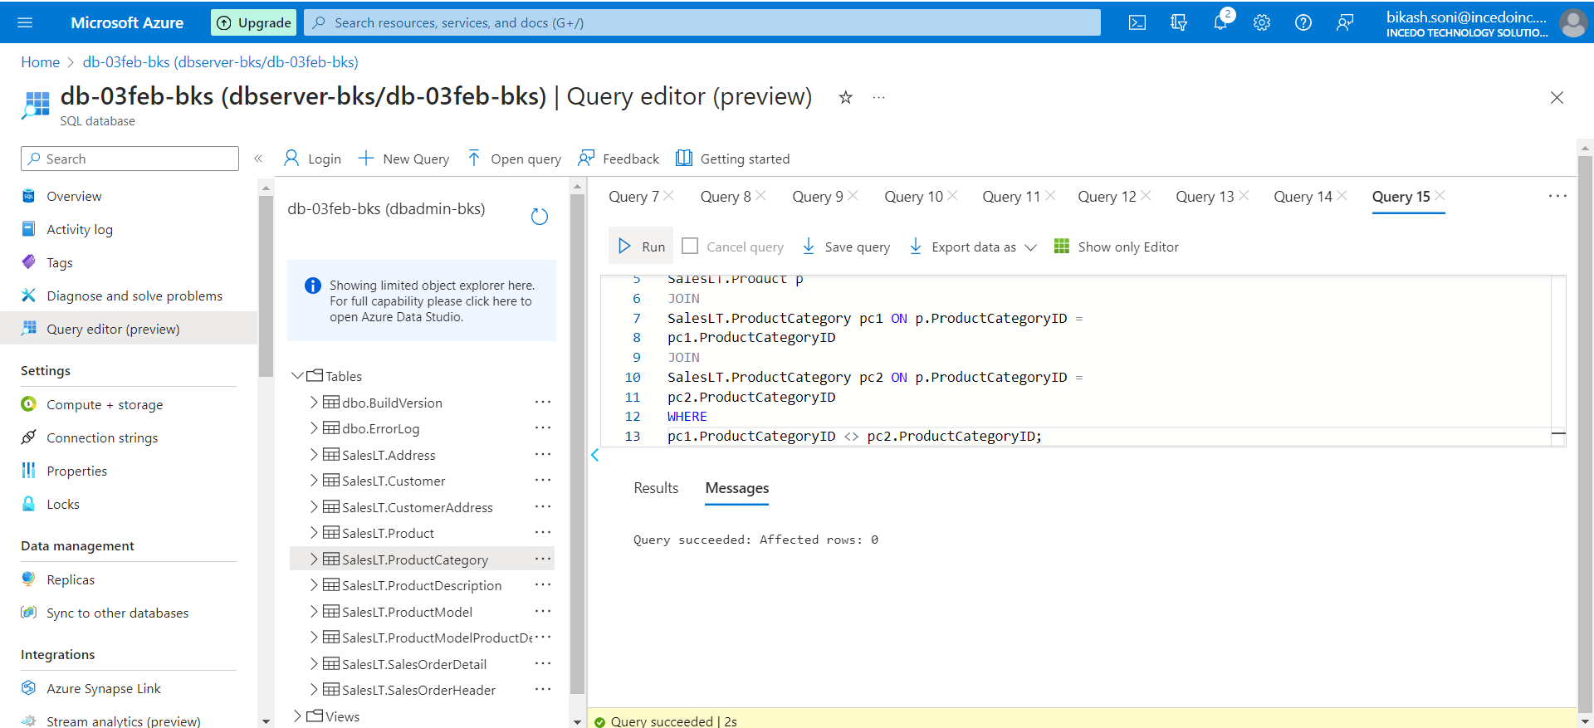

Retrieve product names that are common in two different product categories.

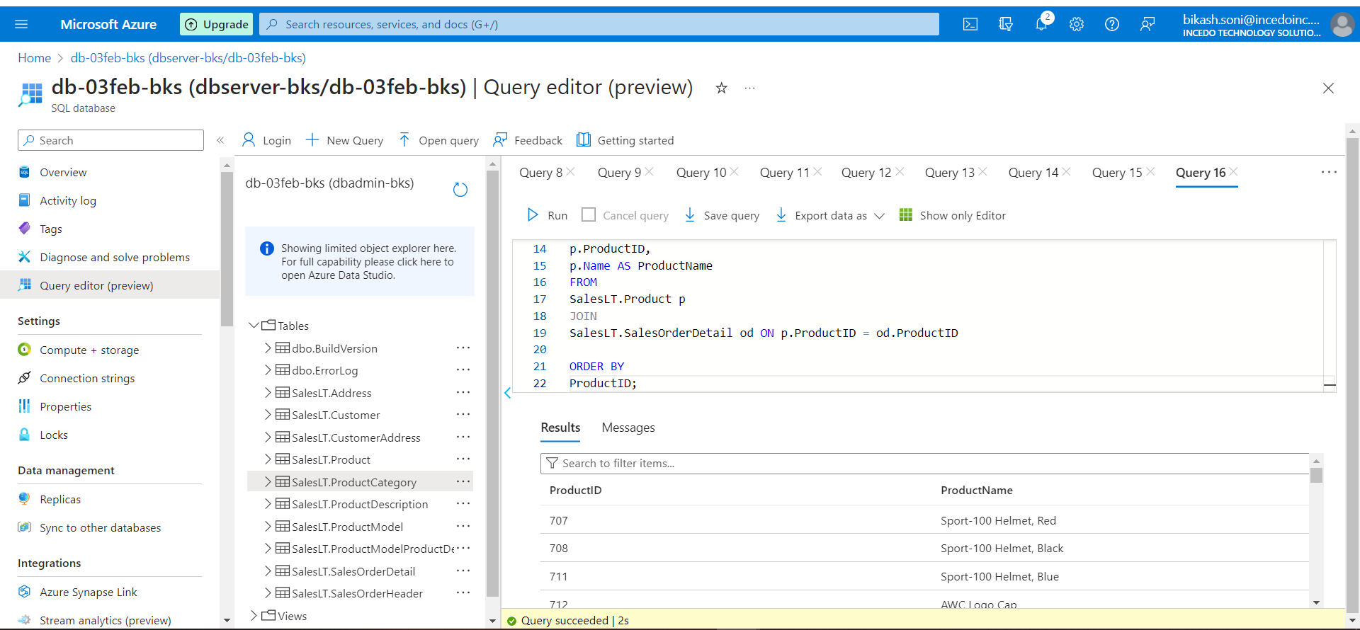

Combine the results of two queries to find unique products ordered by a specific customer.

**Intermediate:-**

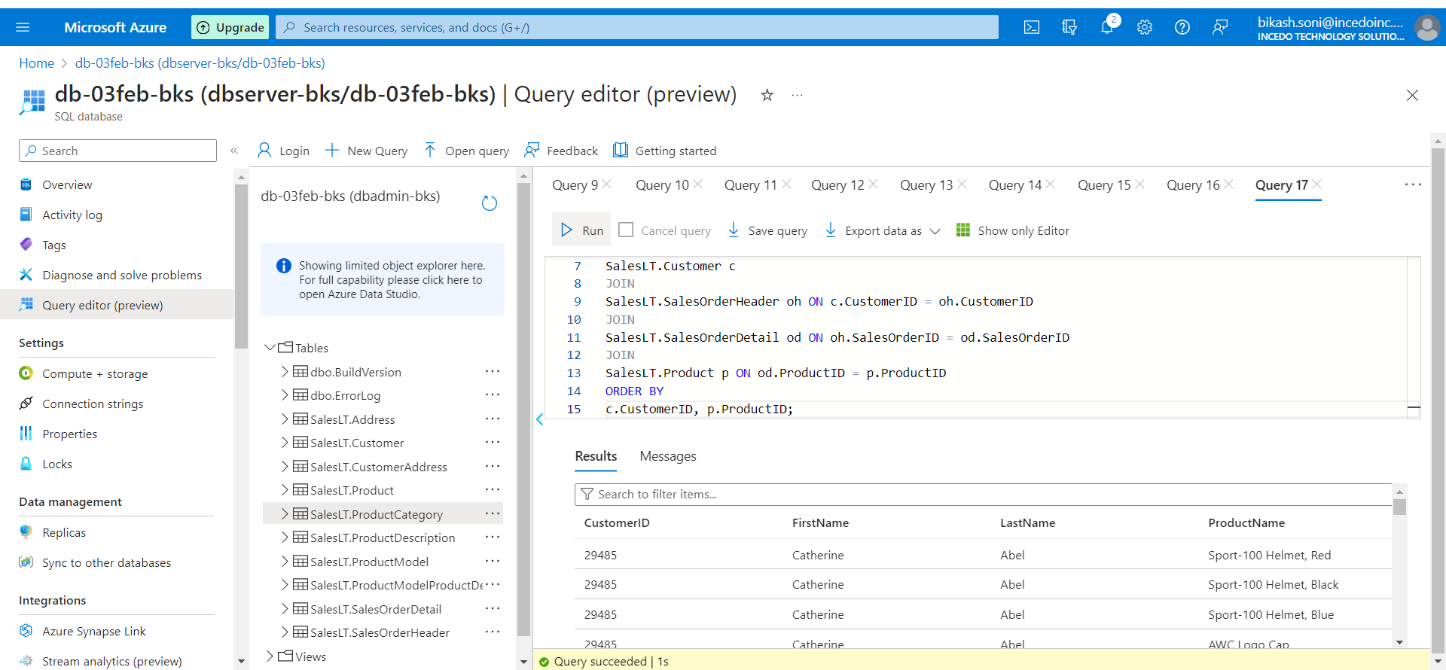

Retrieve a list of customers along with the names of the products they have purchased.

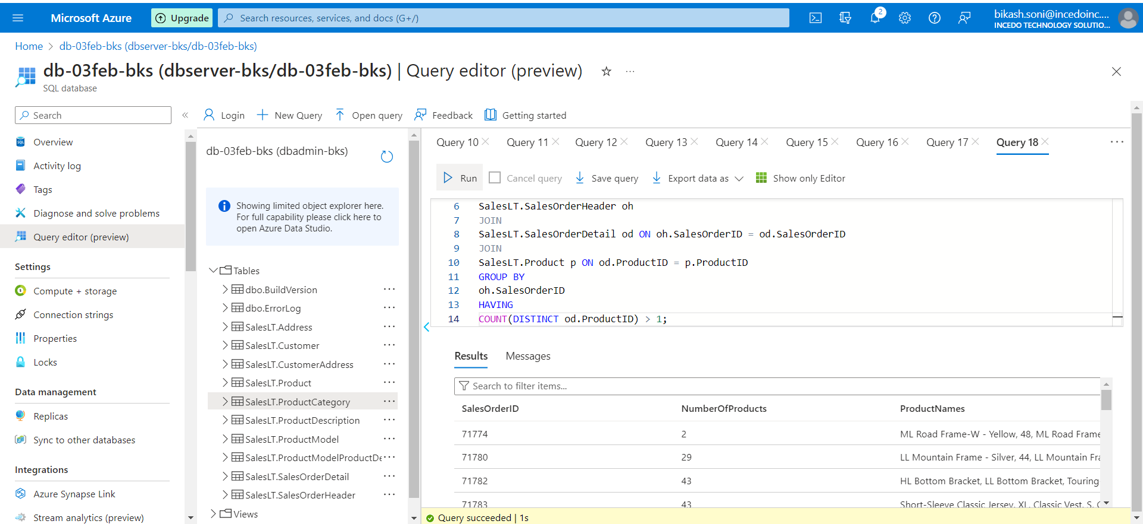

Find orders with multiple products and display the product names.

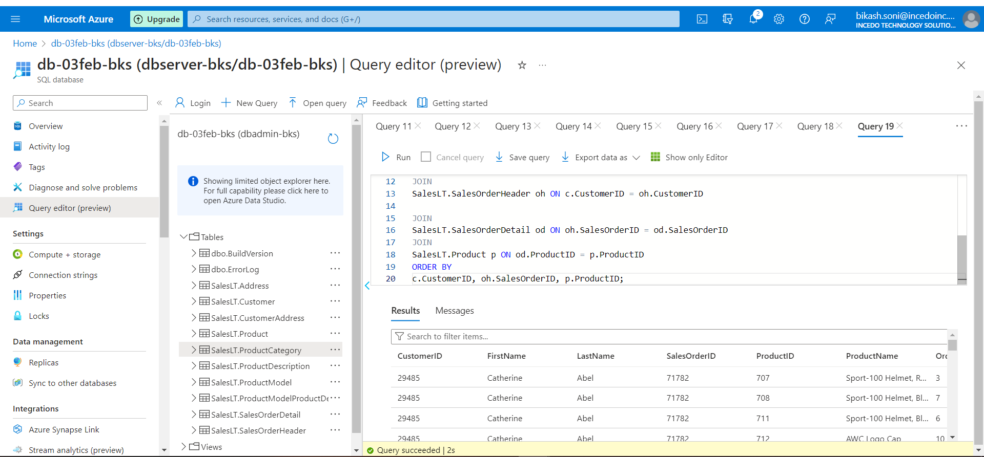

Display customers who have placed orders and the products they have purchased, including product details.

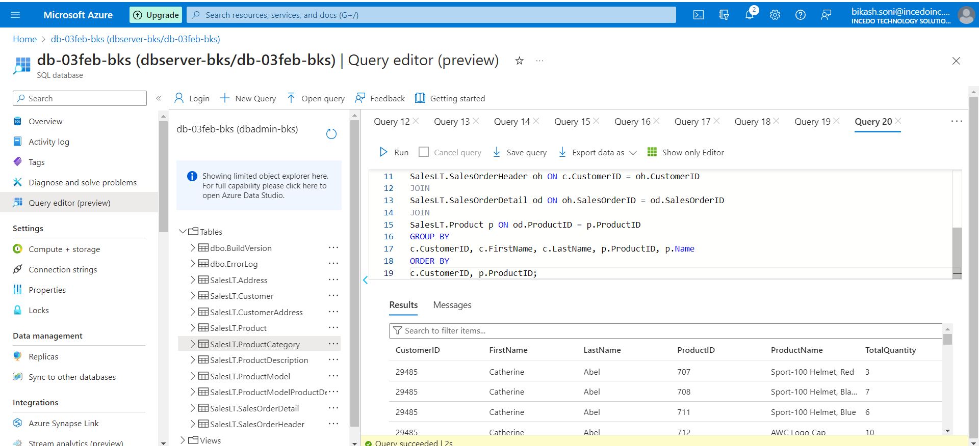

Display customers who have placed orders and the total quantity of each product ordered.

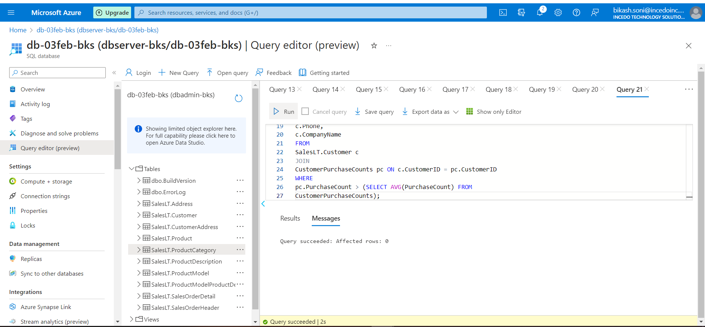 Find customers who have made more purchases than the average number of purchases.

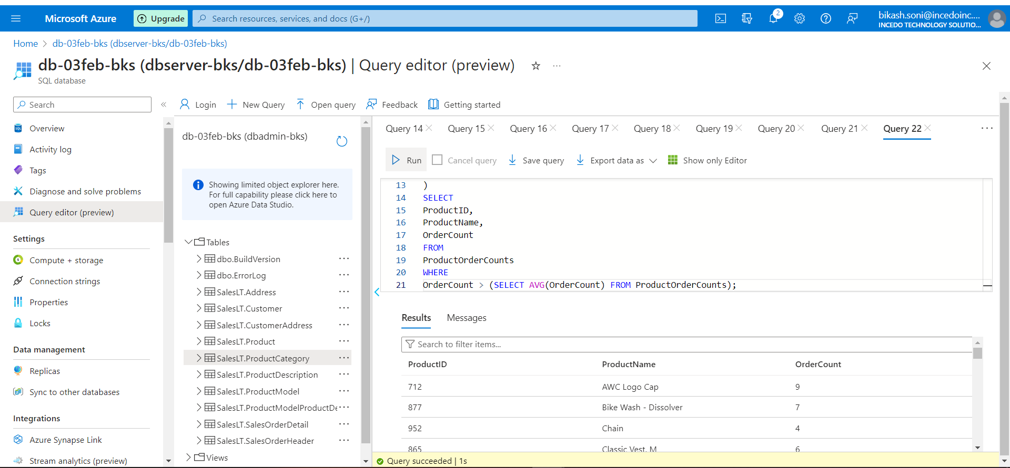

Display products that have been ordered more than the average number of times.

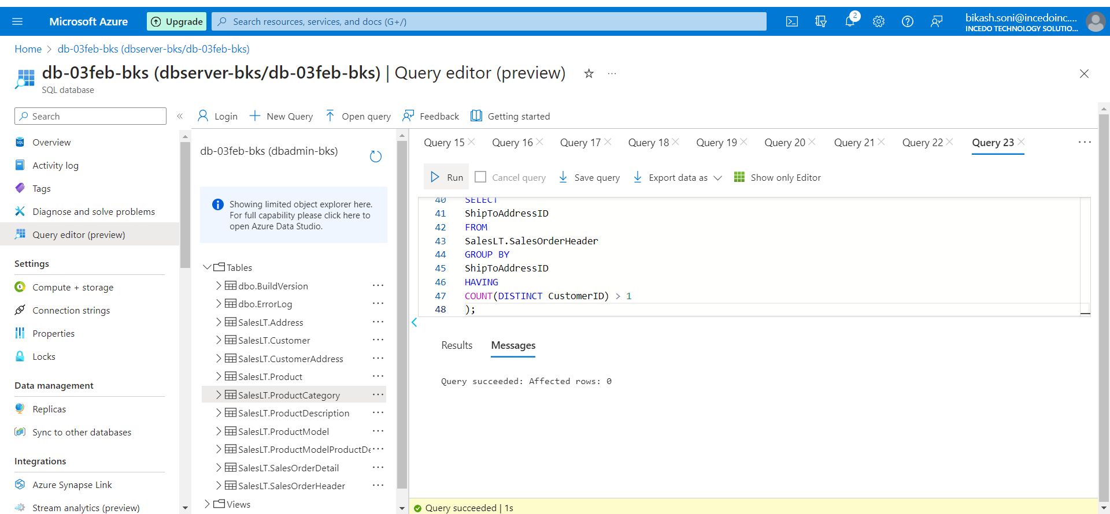

Retrieve products that have been ordered by customers with the same shipping address.